Acceptance test for user story:
Clear button BLAST
Acceptance criteria
Press the clear button. The imported file disappears and the written text is removed.
Test:
User opens the program and first sees main screen.
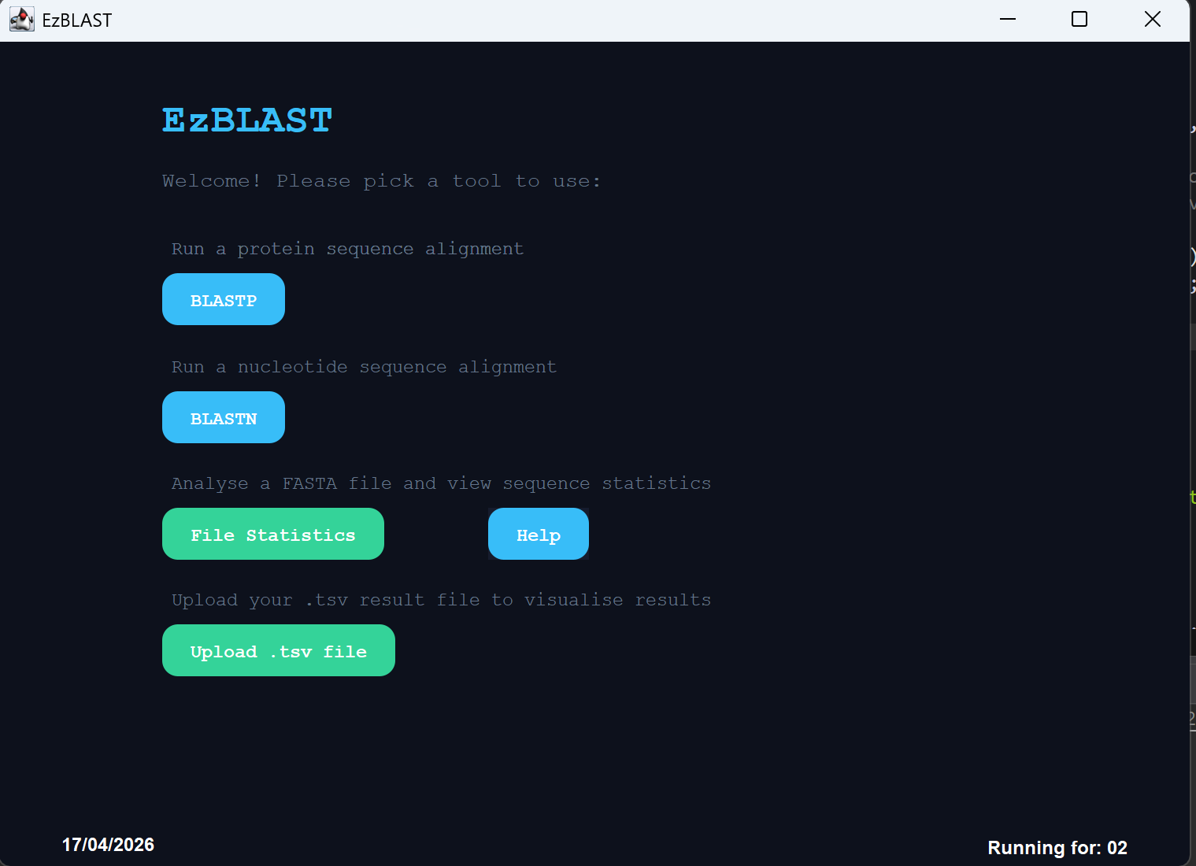
User presses BLASTP button and sees BLASTP screen.
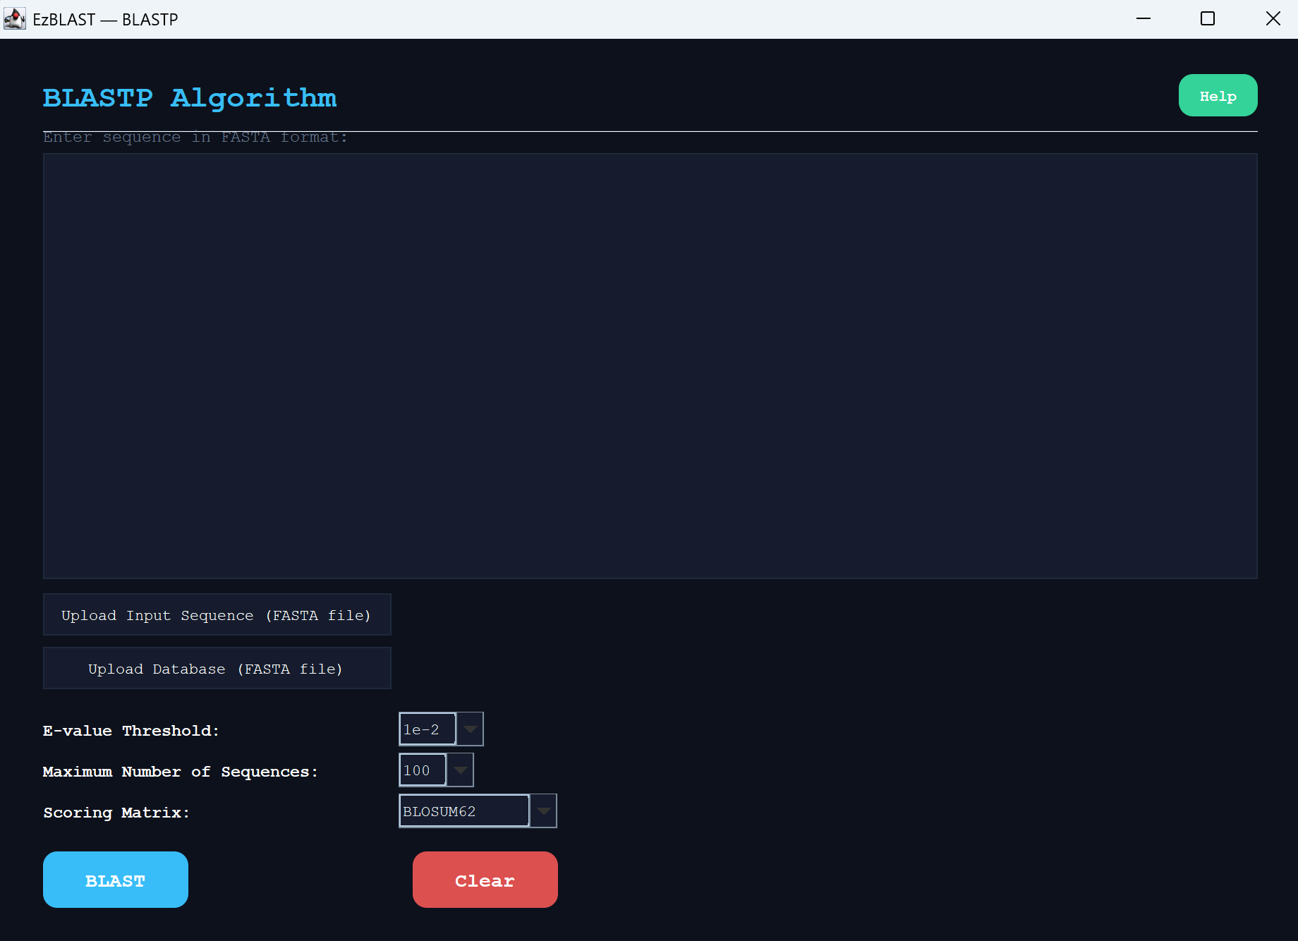
User uploads a file with FASTA format through upload button.
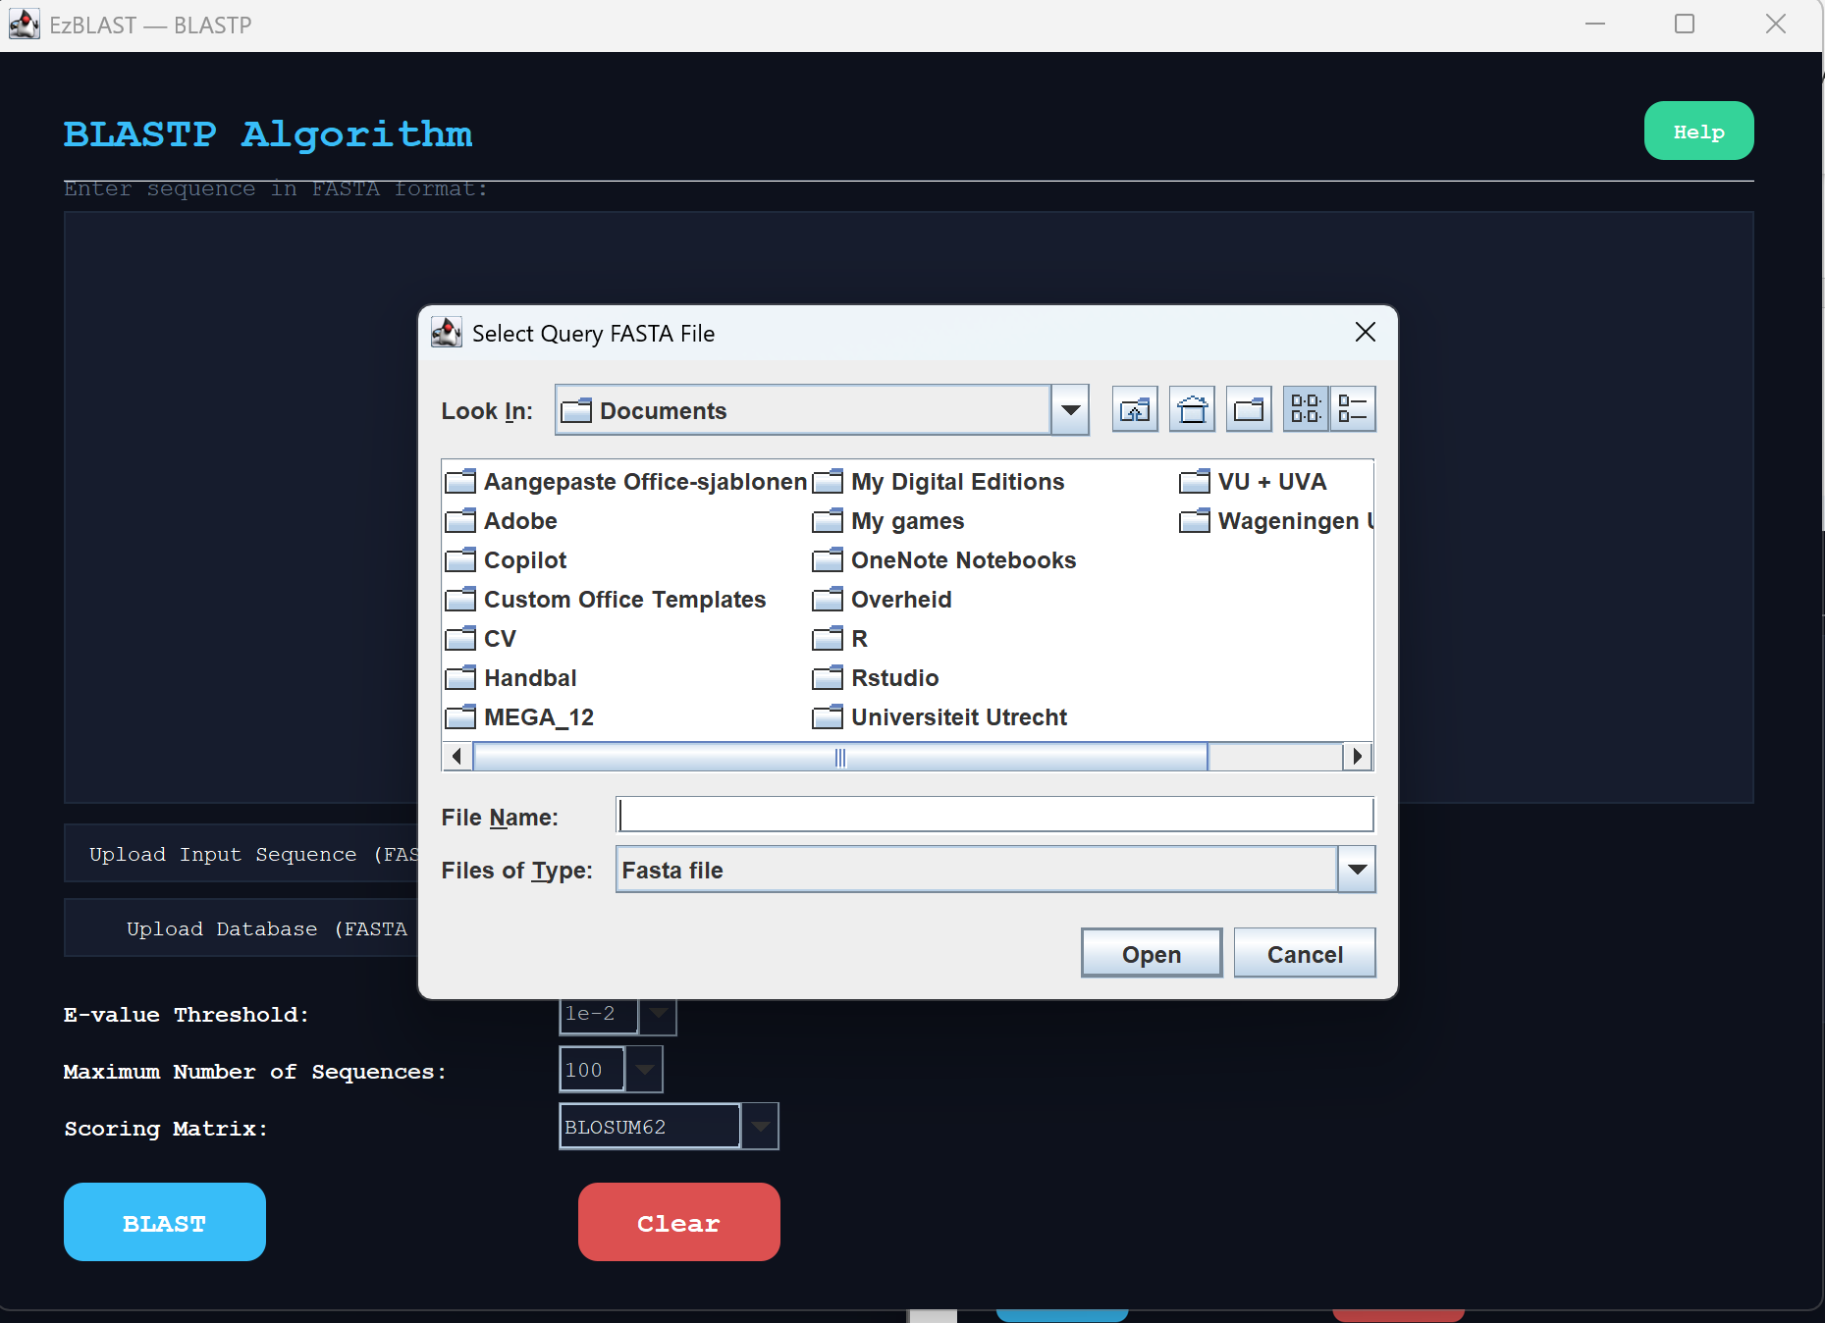
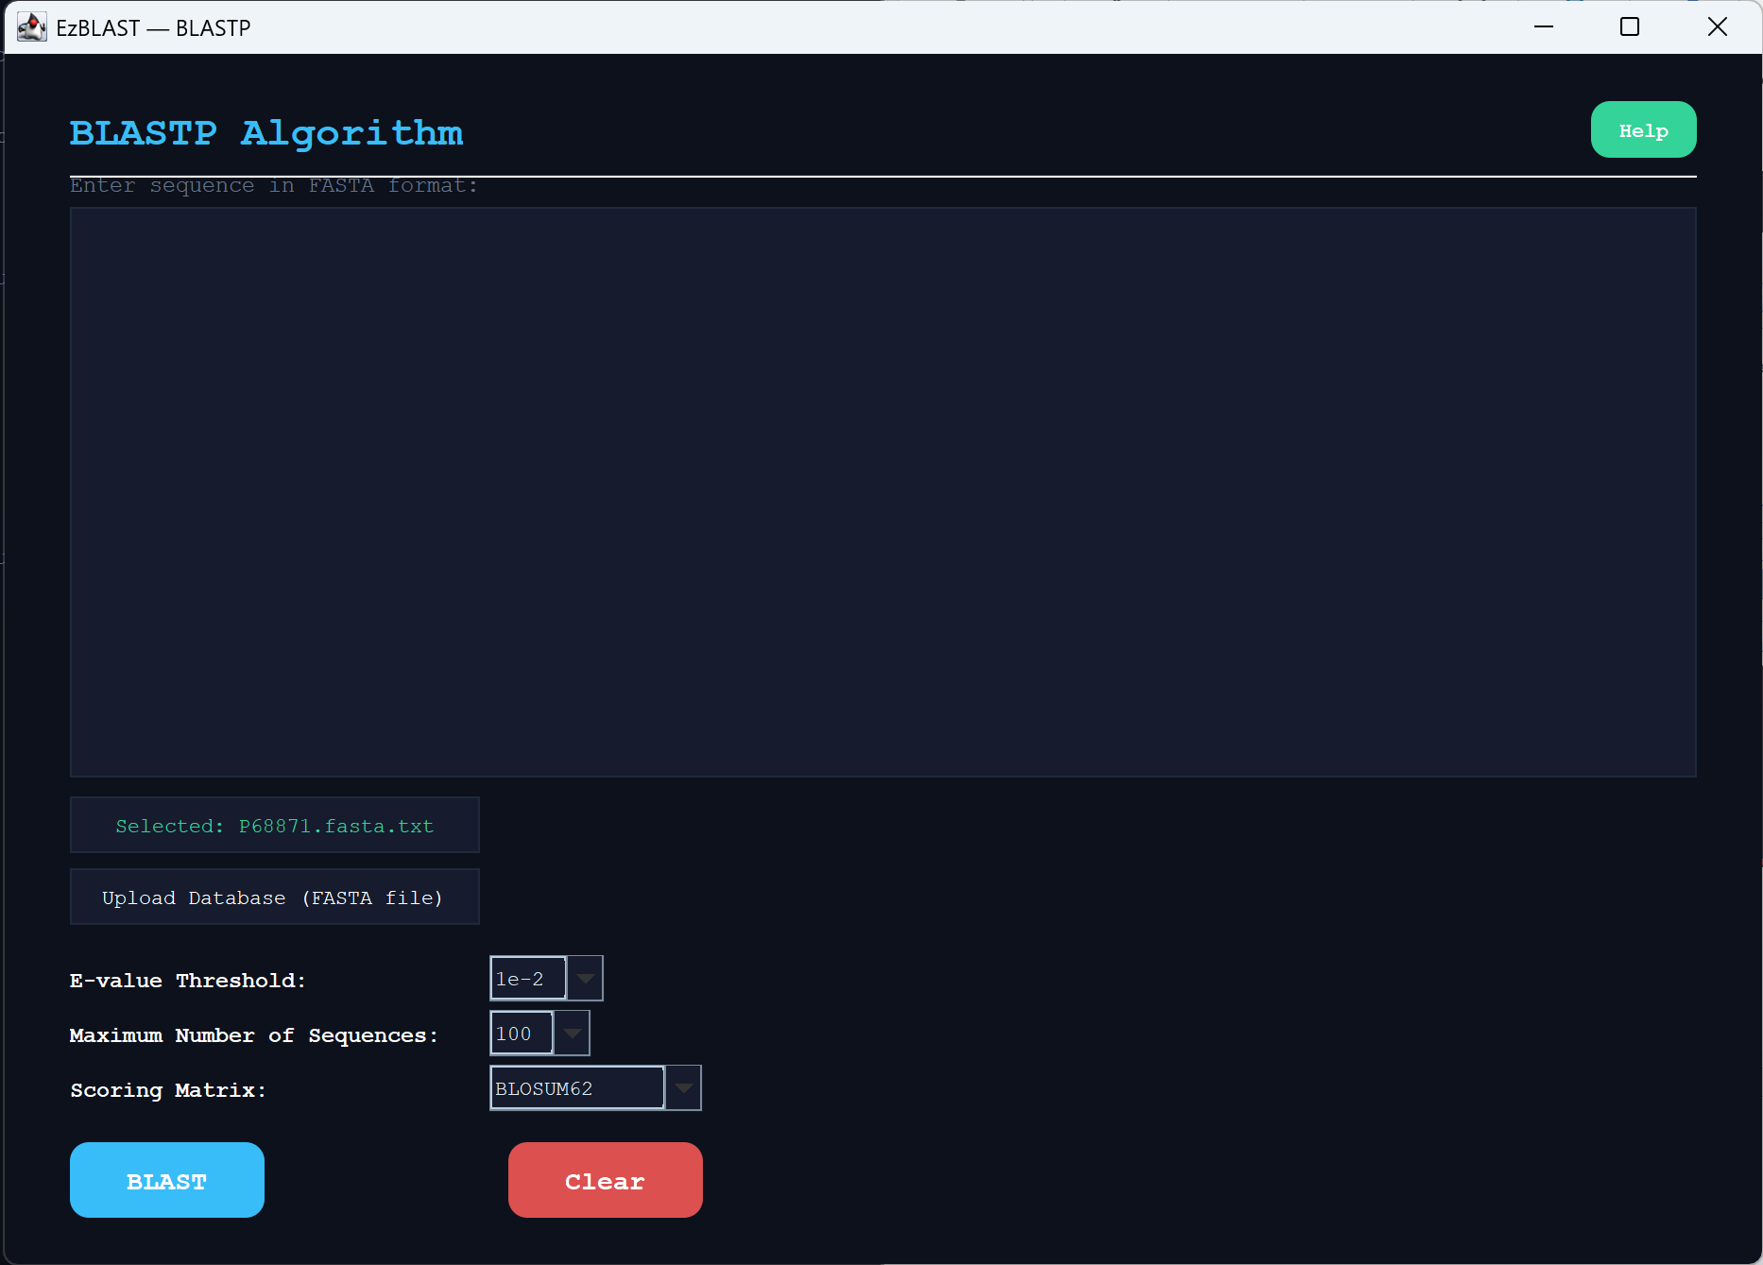
User actually wanted to type a different sequence.
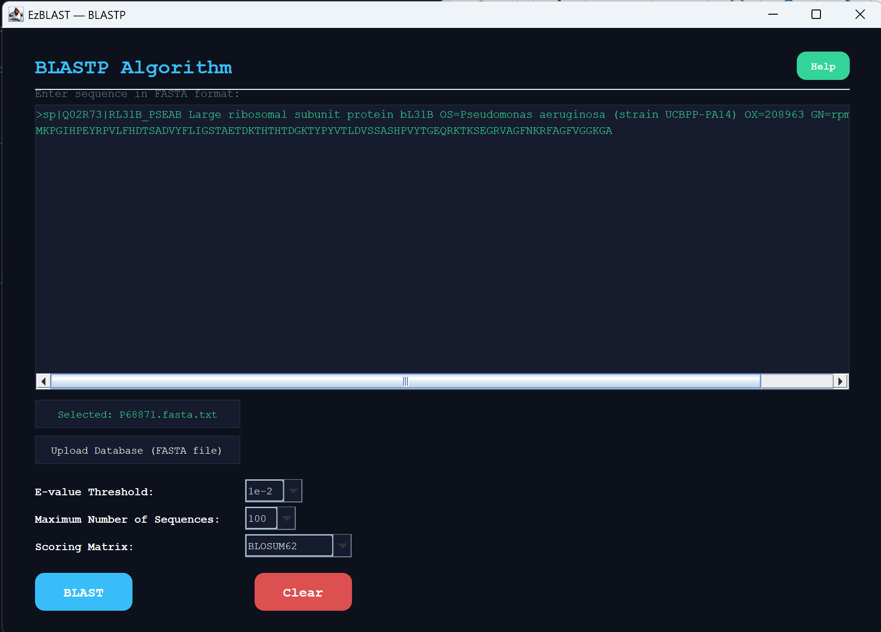
User presses clear button.

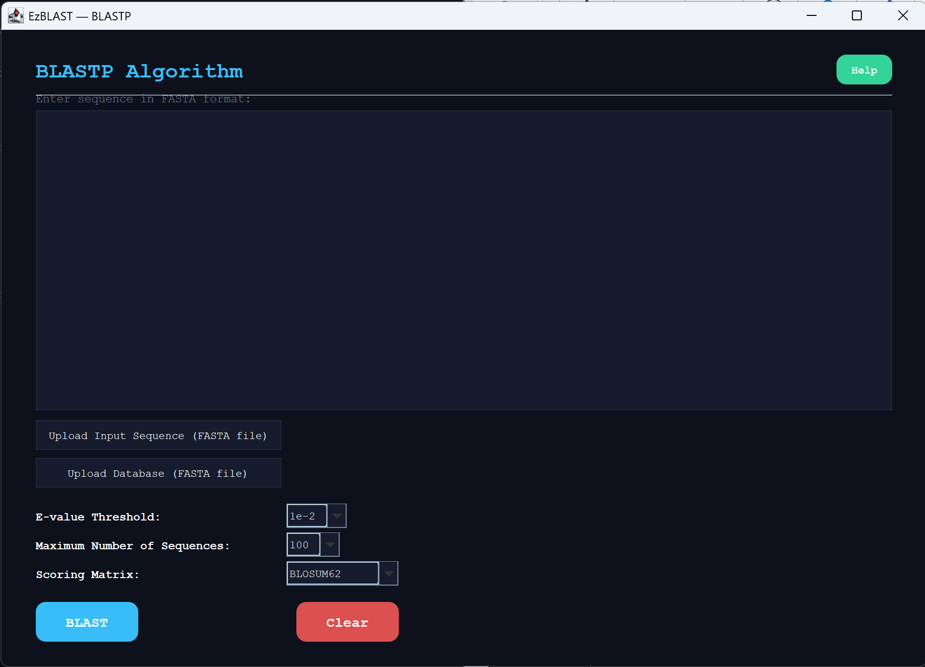
All information has been removed successfully. User can now give their written sequence.

